Use Case Realisation Report - Generate CertificateGENERATE REPORT
FOR
Volunteer Management System
(VMS)

CLIENT
PROJECT | Volunteer Management System (VMS)
TITLE | Use Case Realisation Report - Generate CertificateReport
VERSION | 0.2a0.1a
DATE | 13-Aug-2011
 | ORIGINATOR
 | Name / Signature | Team 8S
 | APPROVAL
 | Name / Signature | Phung Kim Cuong, Dio
Institute of Systems Science |  | Document Reference
25 Heng Mui Keng Terrence  Singapore 119615 |  | VMS/PM-1.3.1/1

 | Acceptance
 | Customer Signature |  | Customer Signature
 | Name & Designation |  | Name & Designation
 | Date & Company Stamp |  | Date & Company Stamp

Revision History

Date | Version | Description | Author
12-Jun-2011 | 0.1a | Creation | Team 8S
11-Aug-2011 | 0.2a | Updated | Team 8S
 |  | Refer to amendment history

Table of Contents

1. Brief Description 3
2. Flow of Events 3
2.1 Standard Flow 3
2.2 Exceptions 3
3. Interaction Diagrams 4
3.1 Collaboration Diagram for Generate Report 4
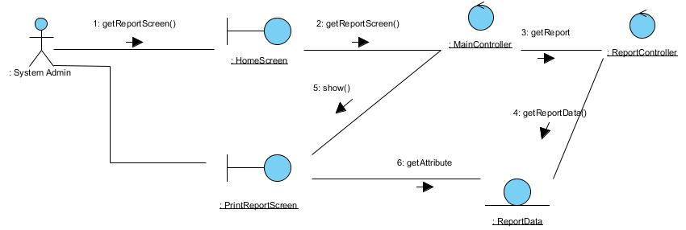 4
4. Participating Objects 4
4.1 ReportData 4
This entity object stores the details data concerning a report. 4
4.2 MainController 4
4.3 ReportController 4
4.4 PrintReportScreen 4
4.5 HomeScreen 4
5. Class Diagrams 5
6. Derived Requirements 5
ANNEX D Amendment History 5

Use Case Realisation Report - Generate Certificate Report

Brief Description
This use case allows the batch scheduler to generate reports based on predefined schedule.

Flow of Events
The standard flow of events for this use case and any exceptions are described in the following subsections. See section 3.1 for an overview of the participating Actors and Domain Objects.

Standard Flow
This use case provides the functionality that will be provided to the batch scheduler as follows:
- When the user clicks ‘Generate Report’ button, the method MainController .getReportScreen() is triggered.
- The MainController.getReportScreen () will use the method ReportController.getReport() to get the report.
- ReportController.getReport () will use the ReportData.getReportData() method to get Report data.
- The printReport screen will show, and get report data for printing.
- The use case terminates

Exceptions
The following exceptions were identified:

Interaction Diagrams

Collaboration Diagram for Generate Report

Participating Objects

ReportData

This entity object stores the details data concerning a report.

MainController
This controller object co-ordinates the menu selection and dispatches of requests of the volunteer management system. It delegates the user requests to the specific use case controller objects for carrying out the use cases.

ReportController
This controler object co-ordinates the generating of a report in the volunteer management system. It receives requests from the boundary objects allocated for the specific purposes, along with all the necessary details required for the execution of these requests.

PrintReportScreen
This boundary object is used for retrieve the request of printing of report. The User actor uses this object.

HomeScreen
This boundary object is used for redirecting and displaying of home screen details and menu. All the user actors use this object.

Class Diagrams
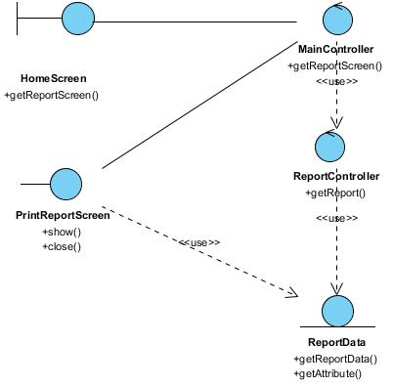

Derived Requirements

ANNEX D Amendment History

This is a record of all amendments made to the Document.
Version | Chapter / Section | Page No | Notes of Amendments or Changes

